class Solution:

def lengthOfLastWord(self, s: str) -> int:

return(len(s.strip().split(' ')[-1]))

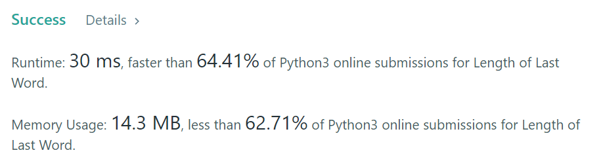.

Others C++ version:

class Solution {

public:

int lengthOfLastWord(string s) {

int len = 0, tail = s.length() - 1;

while (tail >= 0 && s[tail] == ' ') tail--;

while (tail >= 0 && s[tail] != ' ') {

len++;

tail--;

}

return len;

}

};

Same method in python:

class Solution:

def lengthOfLastWord(self, s):

end = len(s) - 1

while end > 0 and s[end] == " ": end -= 1

beg = end

while beg >= 0 and s[beg] != " ": beg -= 1

return end - beg